H.T No
Regulations:
A15


Sreenidhi Institute of Science and Technology
(An Autonomous Institution)
Code No: 5B306 Date: 04-June-2019 (AN)

B.Tech II Year I-Semester External Examination, June-2019 (Supplementary)
MECHANICS OF SOLIDS (ME)

Time: 3 Hours Max.Marks:75

Note: a) No additional answer sheets will be provided.
b) All sub-parts of a question must be answered at one place only, otherwise it will not be valued.
c) Missing data can be assumed suitably.

Part - A Max.Marks:25

Answer all QUESTIONS.

1. | Draw the stress strain diagram for a brittle material. | [3M]
2. | What is meant by principal stress and principal strain? | [3M]
3. | What is meant by point of contraflexure? | [3M]
4. | Draw the shear stress distribution of beam with triangular cross section. | [3M]
5. | State the first and second moment area theorem. | [3M]
6. | What is the difference between thin and thick cylinders? | [2M]
7. | Write the relation between the three elastic moduli. | [2M]
8. | How do you determine the section modulus of hollow shaft with circular cross section? | [2M]
9. | Write the expressions for maximum deflection of cantilever beam with uniform and varying load over the entire length. | [2M]
10. | Draw the Mohr’s circle for Biaxial tension(Like and unequal magnitude) and Biaxial tension(Unlike and equal magnitude). | [2M]
Part – B Max.Marks:50
ANSWER ANY FIVE QUESTIONS. EACH QUESTION CARRIES 10 MARKS.

11. | a) | A circular rod of diameter 16 mm and 500 mm long is subjected to a tensile force 40  kN. The modulus of elasticity for steel may be taken as 200 kN/mm². Find stress, strain and elongation of the bar due to applied load. | [5M]
 | b) | A bronze bar 3 m long with a cross sectional area of 320 mm² is placed between two rigid walls. At a temperature of -20°C, the gap Δ = 25 mm. Find the temperature at which the compressive stress in the bar will be 35 MPa. Use α = 18.0 × 10-6 m/(m·°C) and E = 80 GPa.  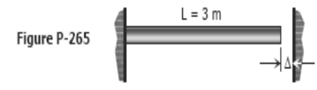 | [5M]
12. | a) | Show that sum of normal stresses in any two mutually perpendicular directions is  constant in case of a general two dimensional stress. | [5M]
 | b) | The state of stress in a material stressed to two-dimensional state of stress is as  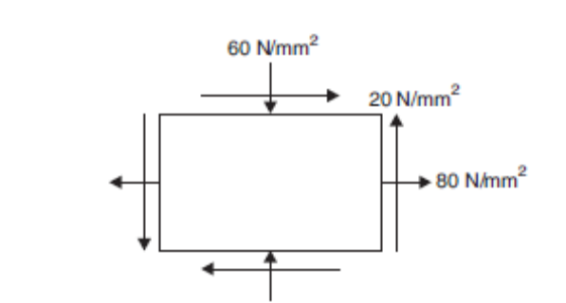  shown in Fig. Determine principal stresses and maximum shear stress and the planes on which they act. | [5M]
13. |  | Draw the shear force and bending moment diagram for the beam shown in fig.  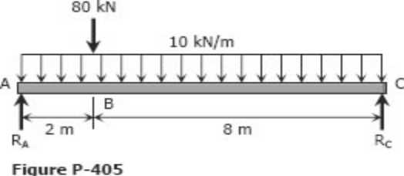 | [10M]
14. |  | 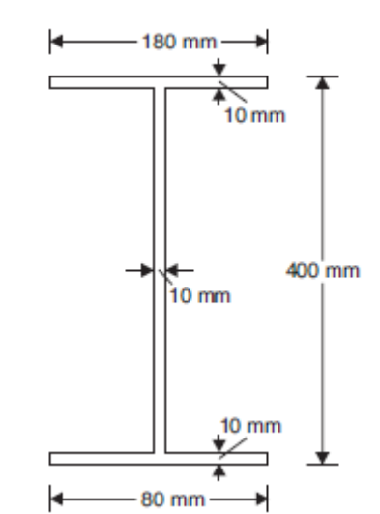  Draw the shear stress variation diagram for the I-section shown in Fig. if it is subjected to a shear force of 100 kN. | [10M]
15. |  | Determine the equation of the deflection curve for a simple beam AB supporting a  uniform load of intensity q . Also, determine the maximum deflection at the middle of the beam and the angles of rotation at the supports.  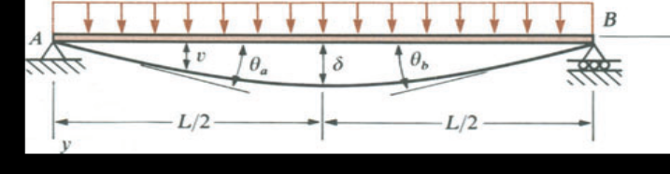 | [10M]
16. |  | Derive the Lame’s equations used to determine the stresses in thick cylinders. | [10M]
17. |  | A hollow shaft and a solid shaft constructed of the same material have the same  length and the same outside radius r . The inside radius of the hollow shaft is 0.6r. Assuming that both shafts are subjected to the same torque, compare the maximum shear stresses, the angles of rotation, and the weights of the two shafts | [10M]
18. |  | Derive the bending equation to determine the stress starting from fundamentals. | [10M]

-- 00 -- 00 –

